COMPANY PROFILE  Squnga'esihle  Trading (Pty) Ltd  ───────────────────  Project Management · Social Facilitation · Housing Development |   BBBEE Level 01  CIDB: PE 1CE, 1GB  NHBRC: 4000023610  CSD: MAAA 1524409
"Building Communities. Delivering Futures. Transforming KwaZulu-Natal."

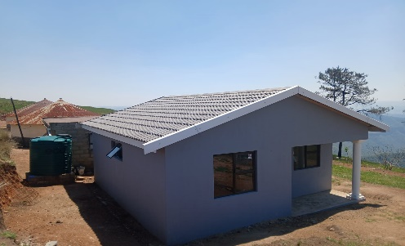 |  | 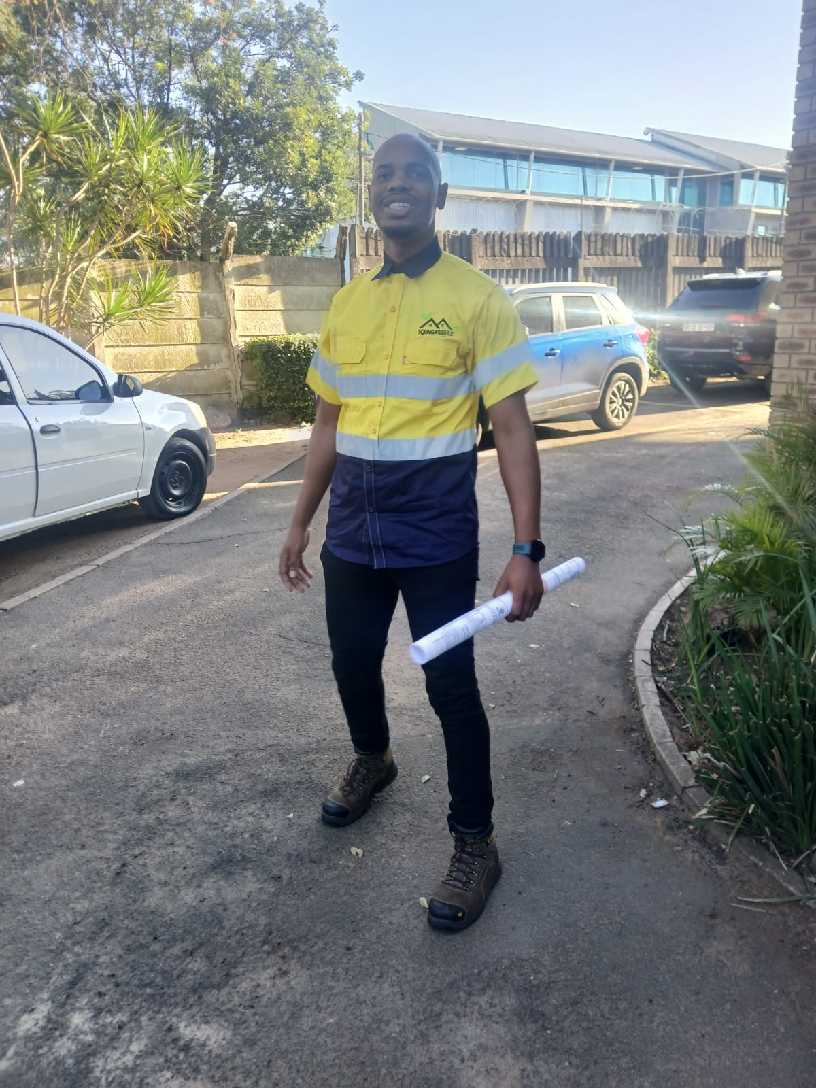 |  | 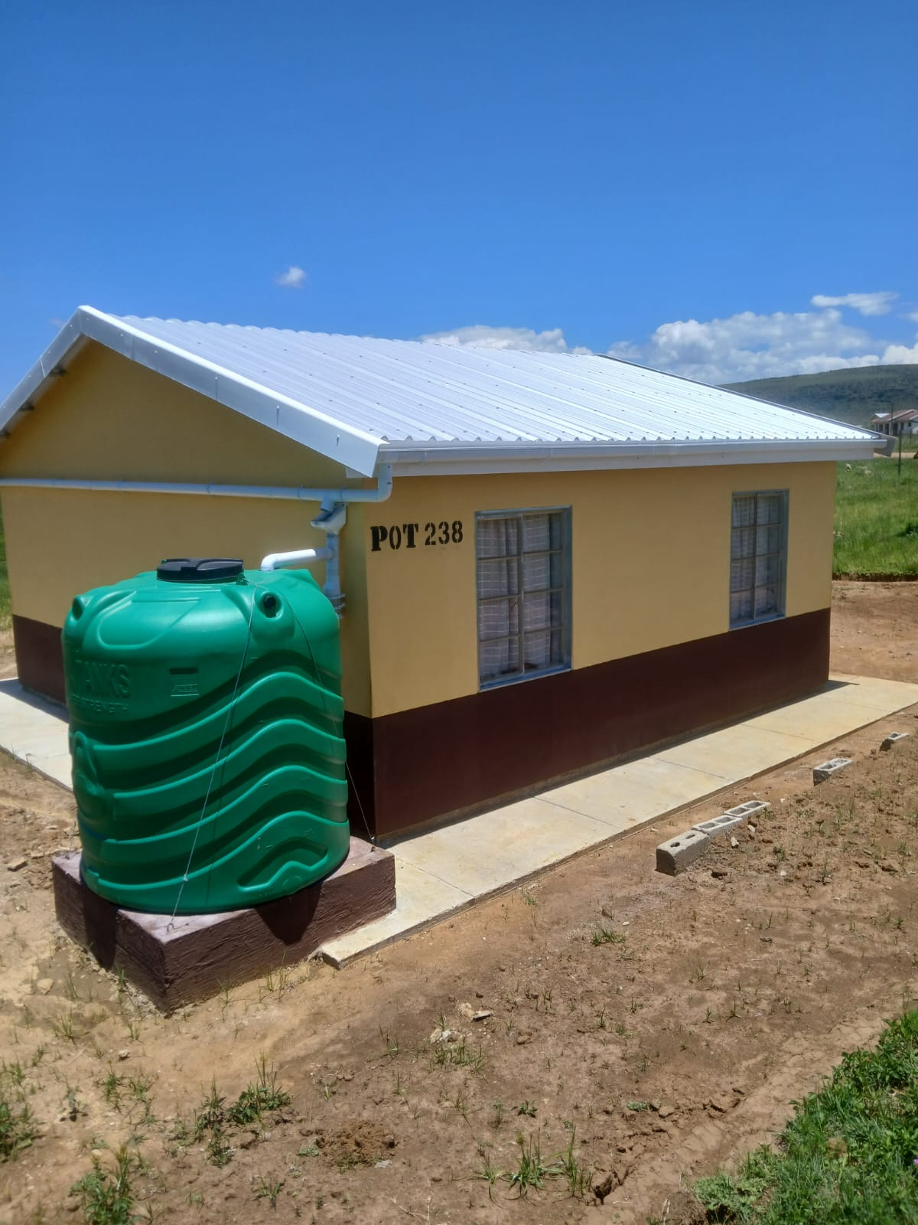

46 Calendula Crescent, Avoca Hills, Durban North, 4001 | squngatrading@mail.com | 064 897 0288

WHO WE ARE
Business Overview

Registration Number | 2024/123222/07
BBBEE Status | Level 01 — Exempt Micro Enterprise
CSD Number | MAAA 1524409
CIDB Registration | CRS: 10418613 | Grade: PE 1CE, 1GB | Expiry: 2029-05-04
NHBRC Registration | Reg No: 4000023610 | Home Builder | Valid: 08/04/2026 – 08/04/2027
Enterprise Type | Proprietary Limited (Pty) Ltd
Core Business | Project Management | Subsidy & Sales Administration | Social Facilitation
Physical Address | 46 Calendula Crescent, Avoca Hills, Durban North, 4001
Contact Number | 064 897 0288
Email Address | squngatrading@mail.com
Chief Executive Officer | Mr. Siboniso Wiseman Cele | 064 897 0288

OUR STORY
Background

Squnga'esihle Trading (Pty) Ltd was founded with a singular and purposeful mandate — to accelerate the capacity and market entry of emerging Implementing Agent companies in South Africa's critical service delivery ecosystem. We are purpose-built for impact: equipped to deliver end-to-end solutions across the Urban and Rural Housing Sector while simultaneously extending our footprint into strategic engineering infrastructure projects.

Our engineering portfolio encompasses internal engineering services, local road access infrastructure, sports and recreation facilities, early childhood development centres (ECD/Crèche), and community hall developments — each project undertaken with the same rigour and commitment to excellence that defines everything we do.

At Squnga'esihle, we understand that true development goes beyond bricks and mortar. It is about people, communities, and the futures we collectively build. Every project we touch represents a community served, a family empowered, and a municipality transformed.

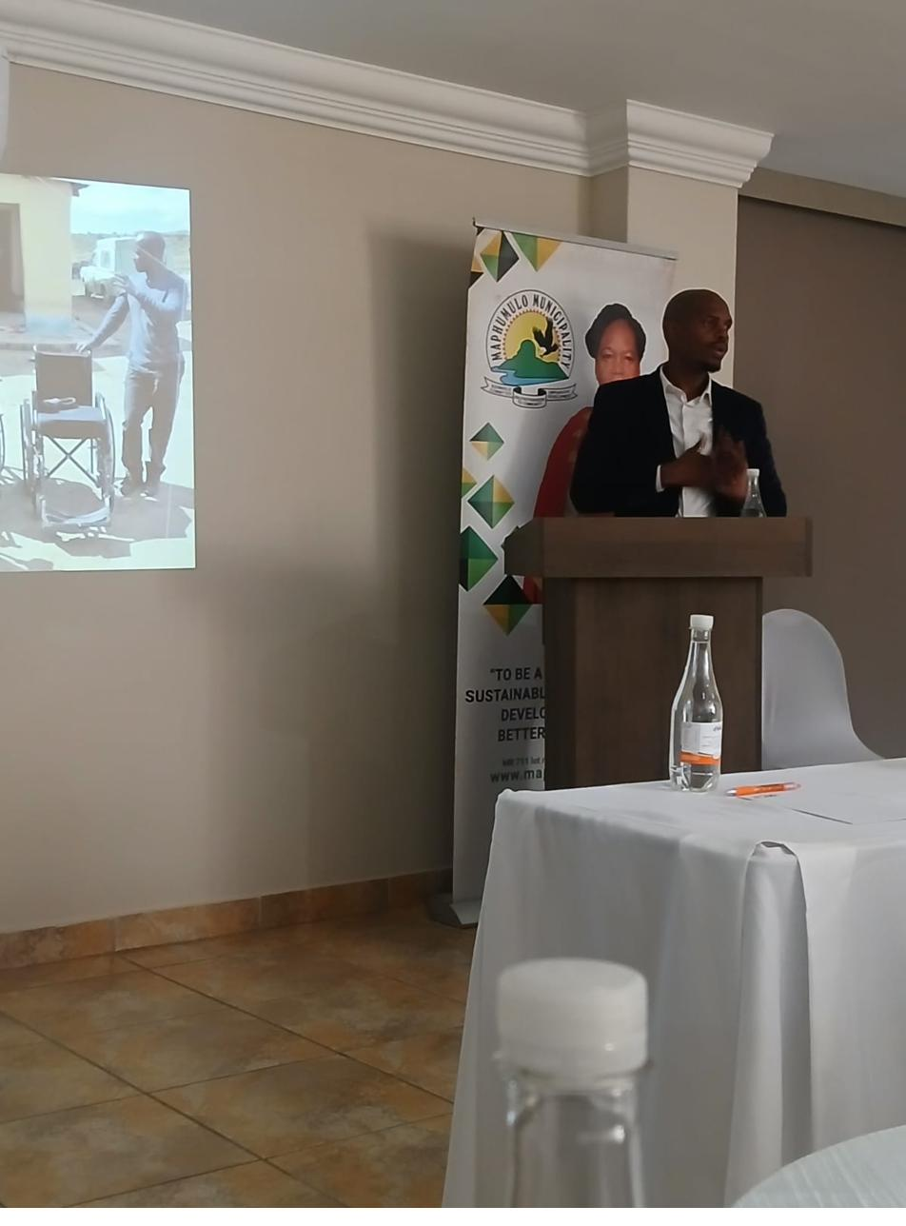  Mr. S.W. Cele — CEO |  | Leadership That Delivers  Our CEO, Mr. Siboniso Wiseman Cele, brings over five years of hands-on experience in KwaZulu-Natal's housing development sector. A graduate of the University of Zululand with a BSc in Geography and Hydrology (2016), and a certified practitioner in Fundamentals of Project Management (2019), he combines academic depth with practical mastery across project management, social facilitation, community engagement, and project administration.

OUR VISION
To be the most trusted and impactful project management and social facilitation enterprise in KwaZulu-Natal — transforming underserved urban and rural communities through visionary housing solutions, driving local economic empowerment, and redefining what equitable service delivery looks like in the municipalities that need it most.

OUR PURPOSE
Mission Statement

Squnga'esihle Trading exists to bridge the gap between vision and delivery in South Africa's housing and development landscape. We achieve this by forging strategic partnerships with industry-leading professionals, offering a fully integrated, end-to-end consulting experience that communities and clients can count on.

Our Three Uncompromising Pillars

01 | Unshakeable Work Ethics  We hold ourselves to the highest standards of professional conduct — on every project, for every client, without exception. Excellence is not an aspiration; it is our baseline.
02 | Contractual Integrity  Our commitment to the letter and spirit of every agreement is absolute. Clients can rely on us to deliver precisely what we promise, within the scope, timeline, and terms agreed.
03 | Relentless Consistency  We never lose sight of our corporate mandate. Every project, every client, every community — we show up fully focused on outcomes that create lasting value and generational change.

WHAT WE DO
Core Service Offerings

PROJECT MANAGEMENT  ▸ Project start-up meetings with clients  ▸ Procurement and management of service providers  ▸ Project kick-off and technical meetings  ▸ Tranche application packaging to DOHS  ▸ Representation at housing forum meetings  ▸ Monthly reporting to DOHS, LM & PSC  ▸ PSC and technical meeting attendance |  | SOCIAL FACILITATION  ▸ Community engagement and stakeholder mapping  ▸ Identification & formation of Community Based Partners  ▸ Electing Project Steering Committees  ▸ Socio-Economic Report compilation  ▸ CBP constitution & Social Compact Agreement  ▸ Co-ordination of all community meetings with accurate minutes  ▸ Community workshopping on development timelines  ▸ Regular PSC establishment and meeting facilitation |  | SUBSIDY & SALES ADMIN  ▸ Beneficiary list compilation  ▸ Completion of all subsidy administration forms  ▸ Submission to DOHS for approval  ▸ GPS coordinates for each approved beneficiary  ▸ P2 GPS survey certification per coordinate point  ▸ SPLUMA submissions  ▸ Site verification and GPS coordinate mapping

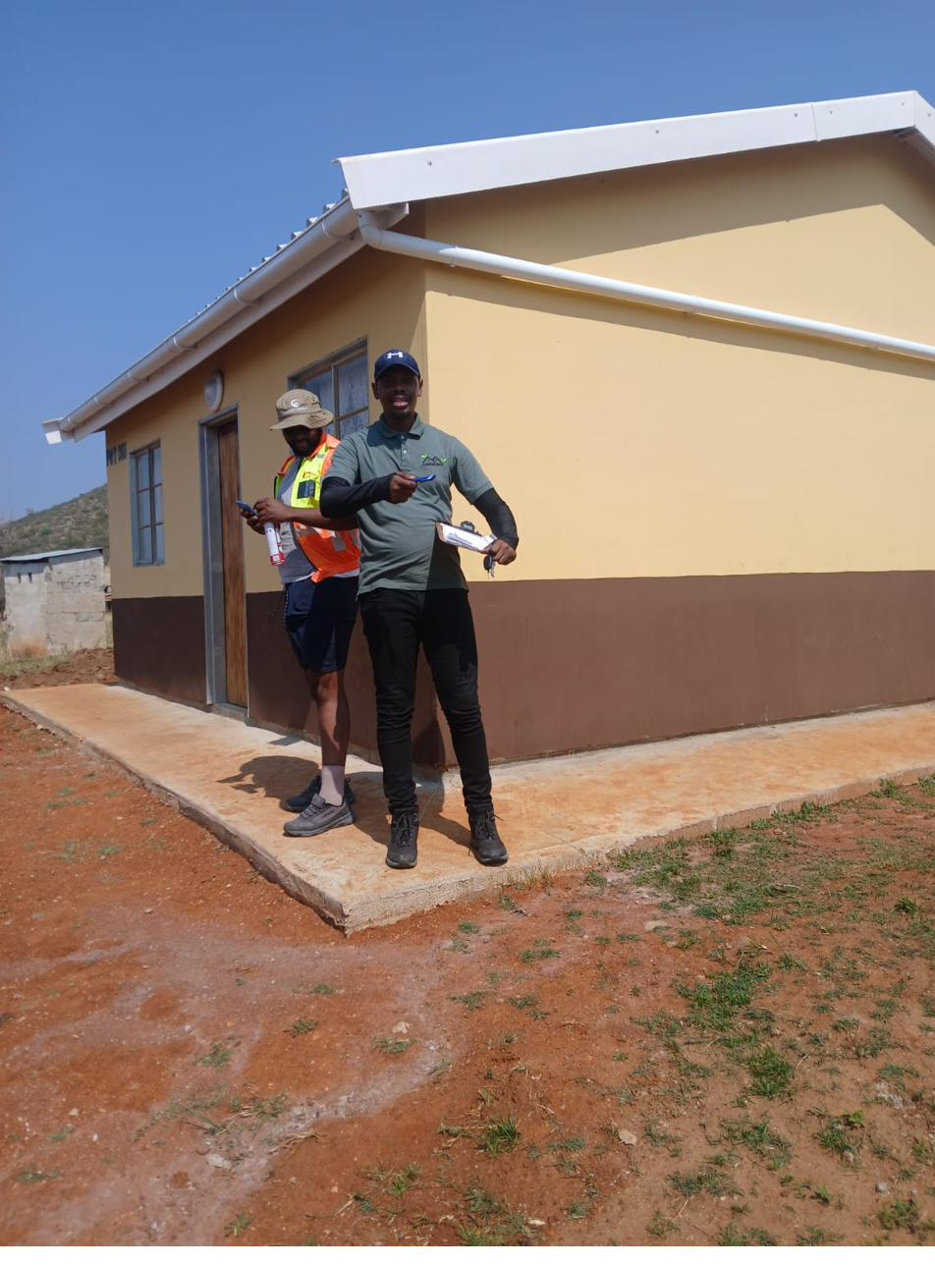 |  | 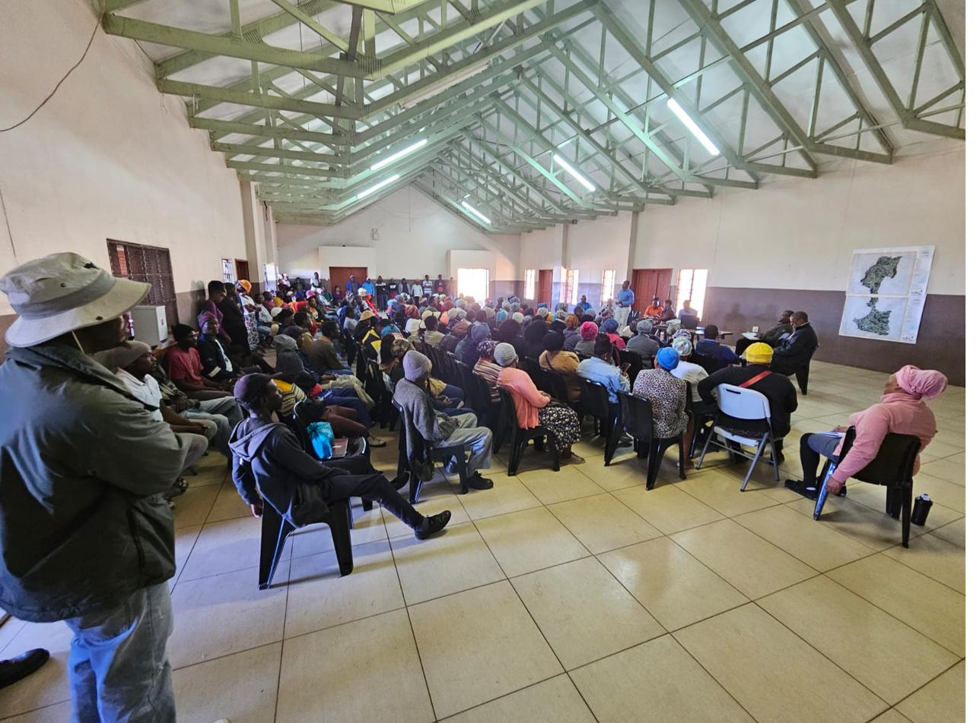

TRACK RECORD
Experience & Expertise

The leadership team of Squnga'esihle Trading brings over five years of hands-on, multi-disciplinary experience in the planning, management, and delivery of low-cost income subsidy housing projects across both urban and rural KwaZulu-Natal. Our portfolio spans thousands of units and reflects a consistent pattern of delivery excellence across all project phases.

Project Management  Strategic project planning and scheduling, appointment and follow-up of professionals, packaging and submission of PLS applications to the Department of Human Settlements, tender briefing attendance and proposal compilation. |  | Social Facilitation  Stakeholder introduction, pre-planning of settlement layouts, CBP formation, constitution assistance, community and traditional authority workshopping on housing policies, Social Compact development, and Implementing Agent agreement management. |  | Beneficiary Administration  End-to-end completion and submission of subsidy application forms, active expediting of approvals with the Department of Human Settlements (DoHS), and meticulous record management throughout.

PORTFOLIO
Project Portfolio

Potshini Rural Housing Project | 1 000 Units
Client: Phumalanga Development
Scope: Project Management & Social Facilitation
Contact: Mr. W. Fenske / Mr. L.G. Ndondo | 082 737 8786
Status: Active — Construction Stage

Edendale EXT 18 Urban Housing Project | 500 Units
Client: Bigen Africa
Scope: Social Facilitation
Contact: Mr. W. Fenske | 082 737 8786
Status: Preliminary Studies Complete — Detailed Studies Underway

Amahlongwa Phase 3 Rural Housing Project | 1 000 Units
Client: Imvusa Trading 595 CC
Scope: Project Management, Social Facilitation, Subsidy & Sales Administration
Contact: Mr. B. Sibiya | 082 788 3499
Status: Preliminary Studies Complete — Detailed Studies Underway

Albersville Urban Housing Project | 100 Units
Client: Zamimpilo Consultant
Scope: Project Management & Social Facilitation
Contact: Mr. L.G. Ndondo / Mr. W. Fenske | 084 764 2013 / 082 737 8786
Status: Stage 1 — Active

Swayimane Rural Housing Project, Ward 08 | 1 000 Units
Client: uPhenyo Trading
Scope: Project Management & Social Facilitation
Contact: Mrs. C. Mtshali | 079 291 3007
Status: Preliminary Studies Complete

CREDENTIALS
Accreditations & Certifications

Squnga'esihle Trading (Pty) Ltd holds active registrations with the two most critical industry regulatory bodies in South Africa's construction and housing sector. These accreditations are a testament to our commitment to compliance, quality, and operating at the highest professional standards.

CIDB — Construction Industry Development Board
CRS Number  10418613 | Grade  PE 1CE, 1GB | Status  Active | Expiry  2029-05-04

NHBRC — National Home Builders Registration Council
Reg Number  4000023610 | Category  Home Builder | Issued  08/04/2026 | Expiry  08/04/2027

PAST PROJECT

RE – INFORCING ENGINEERING |  | CONCRETE FOUNDATION PHASE
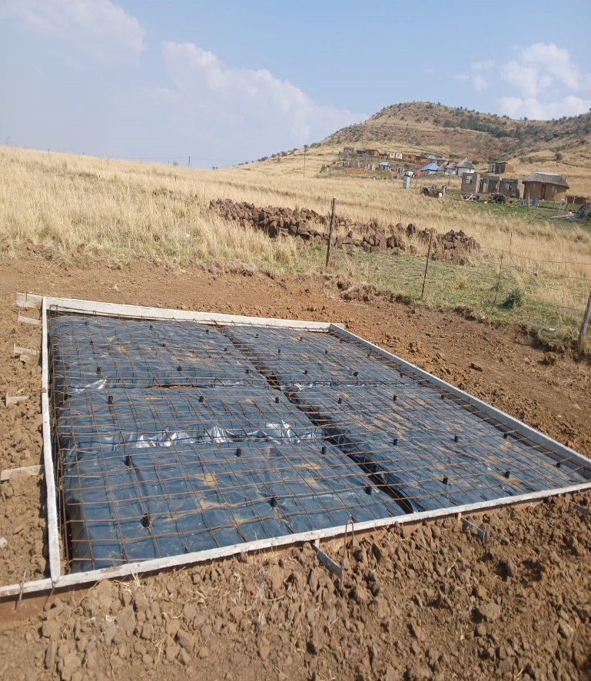 |  | 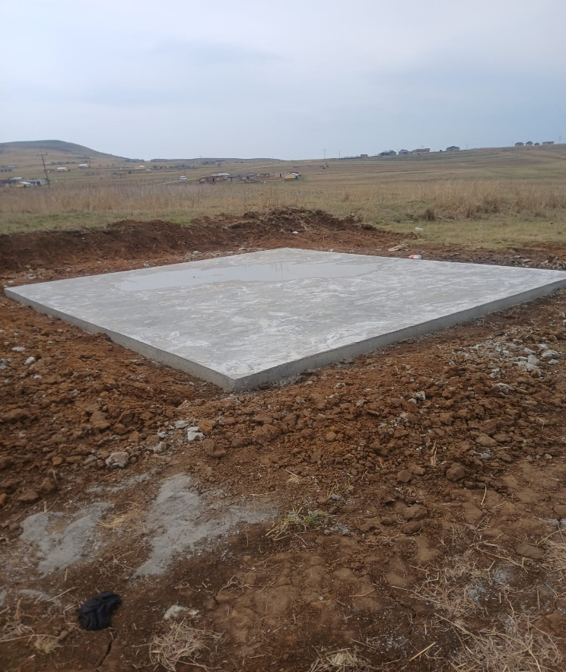

WHY CHOOSE US
We do not simply execute projects — we invest in communities, elevate local economies, and create the conditions for sustainable human dignity.

BBBEE Level 01  Certified & compliant |  | CIDB Grade 1  PE 1CE, 1GB |  | NHBRC Registered  Home Builder |  | 5+ Years  Sector experience |  | 3 500+ Units  Under management

REACH OUT
Contact Us

HEAD OFFICE  46 Calendula Crescent  Avoca Hills, Durban North  KwaZulu-Natal, 4001  📞 064 897 0288  ✉ squngatrading@mail.com |  | CHIEF EXECUTIVE OFFICER  Mr. Siboniso Wiseman Cele  BSc Geography & Hydrology (2016)  Fundamentals of Project Management (2019)  📞 064 897 0288

Squnga'esihle Trading (Pty) Ltd | Reg. 2024/123222/07 | CIDB: 10418613 | NHBRC: 4000023610 | BBBEE Level 01
Building Communities. Delivering Futures. Transforming KwaZulu-Natal.

